**TÍNH TÍCH CHẬP MA TRẬN – Bài 1**



**Câu 1.**

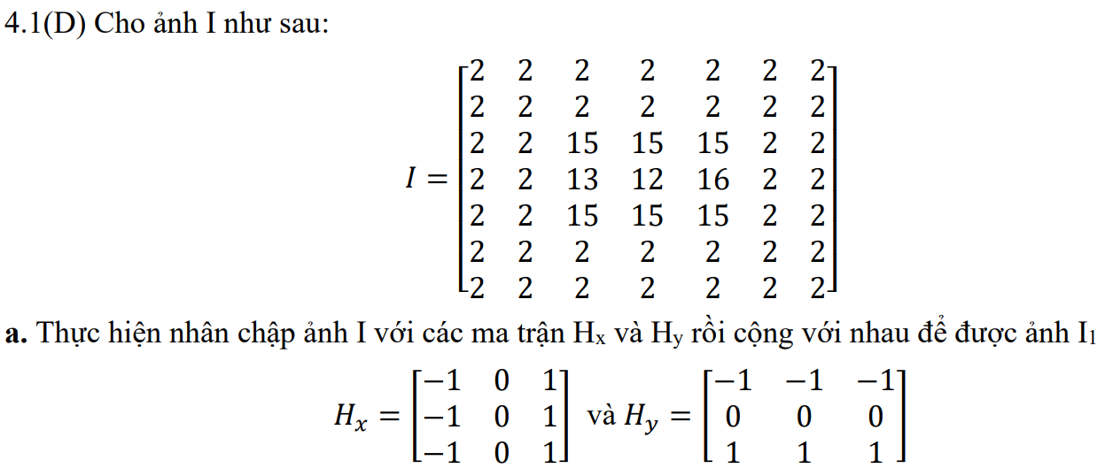

**Giải**

|  |  |  |  |  |  |  |  |  |  |  |  |  |  |  |  |  |  |  |  |  |  |  |  |  |  |  |  |  |  |  |  |  |  |  |  |  |  |  |  |  |  |  |  |  |  |  |  |  |  |  |  |  |  |  |  |  |  |  |  |  |  |  |  |  |  |  |  |  |  |  |  |  |  |  |  |  |  |  |  |  |  |  |  |  |  |  |  |  |  |  |  |  |  |  |  |  |  |  |  |
| --- | --- | --- | --- | --- | --- | --- | --- | --- | --- | --- | --- | --- | --- | --- | --- | --- | --- | --- | --- | --- | --- | --- | --- | --- | --- | --- | --- | --- | --- | --- | --- | --- | --- | --- | --- | --- | --- | --- | --- | --- | --- | --- | --- | --- | --- | --- | --- | --- | --- | --- | --- | --- | --- | --- | --- | --- | --- | --- | --- | --- | --- | --- | --- | --- | --- | --- | --- | --- | --- | --- | --- | --- | --- | --- | --- | --- | --- | --- | --- | --- | --- | --- | --- | --- | --- | --- | --- | --- | --- | --- | --- | --- | --- | --- | --- | --- | --- | --- | --- |
| **Đáp án IHx**   |  |  |  |  |  |  |  | | --- | --- | --- | --- | --- | --- | --- | | 4 | 0 | 0 | 0 | 0 | 0 | -4 | | 6 | 13 | 13 | 0 | -13 | -13 | -6 | | 6 | 24 | 23 | 3 | -23 | -27 | -6 | | 6 | 37 | 36 | 3 | -36 | -40 | -6 | | 6 | 24 | 23 | 3 | -23 | -27 | -6 | | 6 | 13 | 13 | 0 | -13 | -13 | -6 | | 4 | 0 | 0 | 0 | 0 | 0 | -4 | | **Đáp án IHy**   |  |  |  |  |  |  |  | | --- | --- | --- | --- | --- | --- | --- | | 4 | 6 | 6 | 6 | 6 | 6 | 4 | | 0 | 13 | 26 | 39 | 26 | 13 | 0 | | 0 | 11 | 21 | 35 | 24 | 14 | 0 | | 0 | 0 | 0 | 0 | 0 | 0 | 0 | | 0 | -11 | -21 | -35 | -24 | -14 | 0 | | 0 | -13 | -26 | -39 | -26 | -13 | 0 | | -4 | -6 | -6 | -6 | -6 | -6 | -4 | |

**Vậy I1:**

|  |  |  |  |  |  |  |
| --- | --- | --- | --- | --- | --- | --- |
| 8 | 6 | 6 | 6 | 6 | 6 | 8 |
| 6 | 26 | 39 | 39 | 39 | 26 | 6 |
| 6 | 35 | 44 | 38 | 47 | 41 | 6 |
| 6 | 37 | 36 | 3 | -36 | -40 | 6 |
| 6 | 35 | 44 | 38 | 47 | 41 | 6 |
| 6 | 26 | 39 | 39 | 39 | 26 | 6 |
| 8 | 6 | 6 | 6 | 6 | 6 | 8 |